**Server:** [**http://10.75.205.122/esd**](http://10.75.205.122/esd) **Database:** Data Source=10.75.205.8;Initial Catalog=Build65_Upgradetest;Integrated Security=True; **Phase 2 delivery verification**  
  
1. In Browse catalog page, the 'Cross' in search text box needs to change the color to grey and suggestions fly down width should be the size of the search text box.

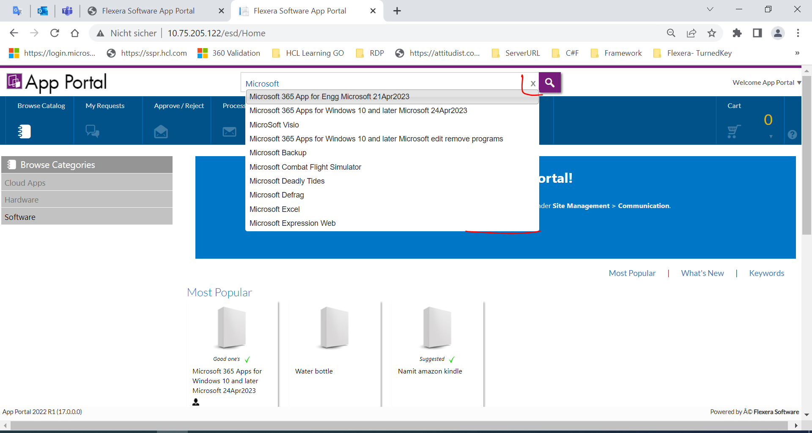

2. The behavior of the ‘Search key’ in Browse catalog page and the 'ENTER' key in keyboard to render the search results are different.

Hit Enter  
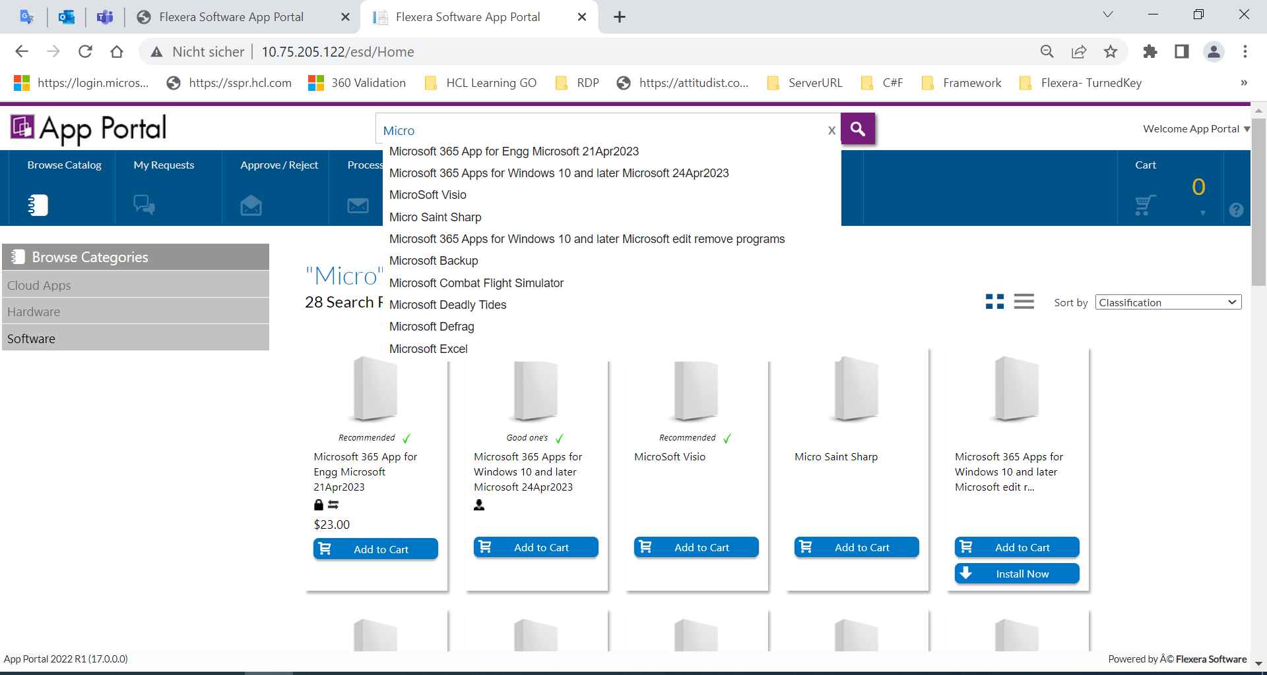

Clicked on Search Icon

3. In Browse catalog page clearing the search text box and empty it and hit on the search icon is NOT doing anything.

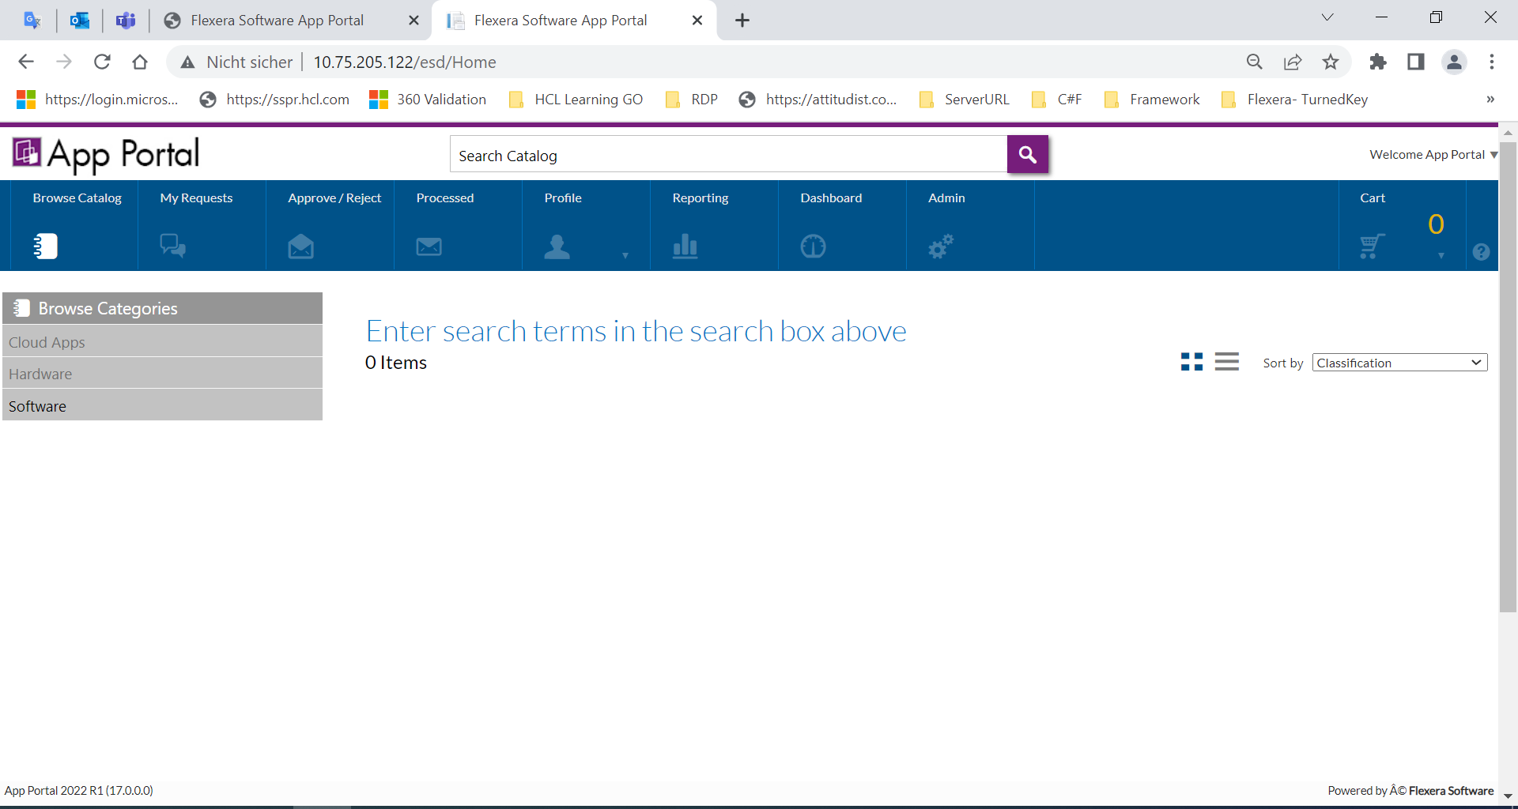

4. While searching for 'Preferred' catalog items even non-preferred catalog items are also getting displayed and vice versa.

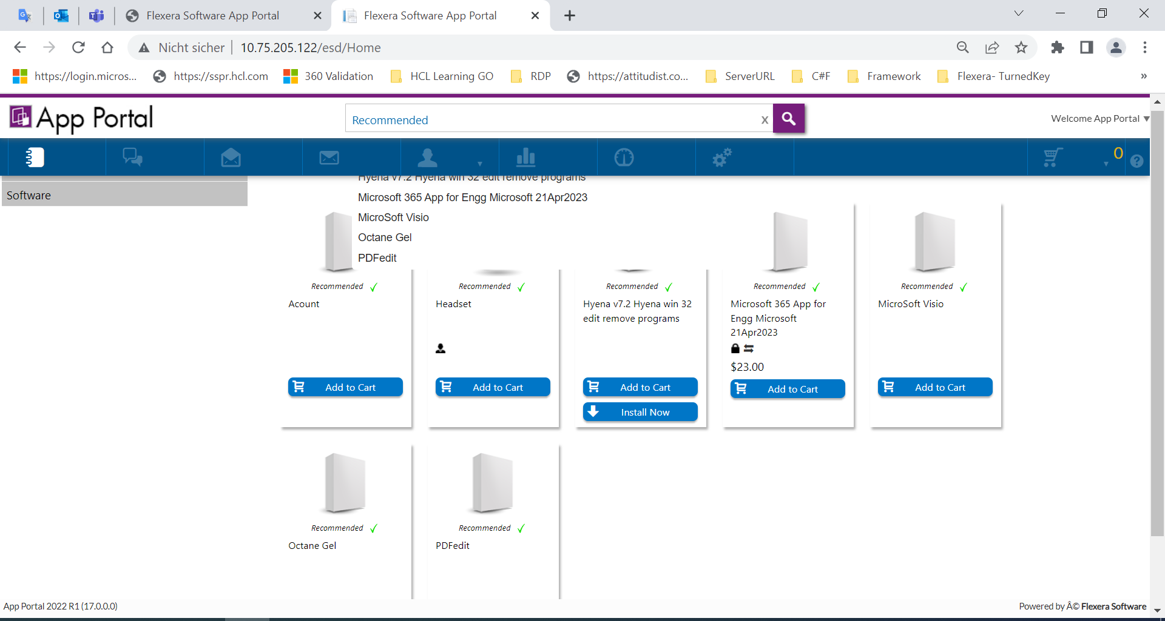

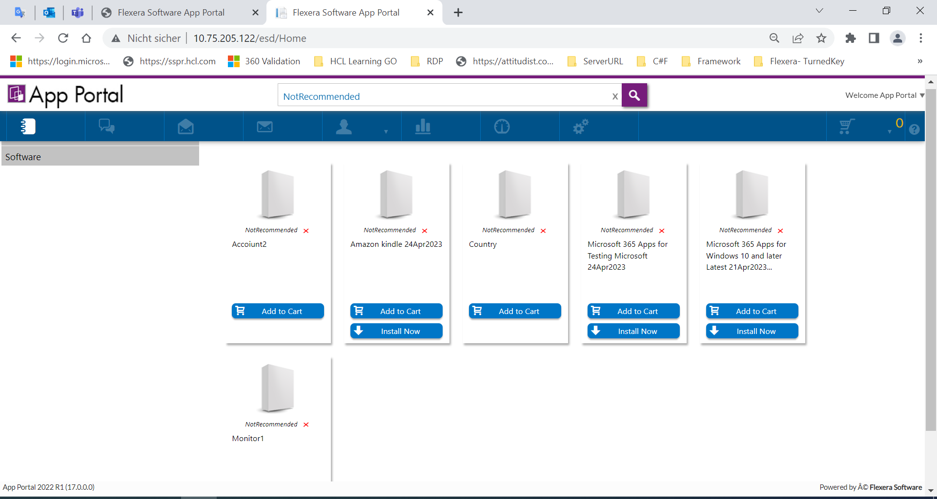

5. Two correct words search without space like ‘MicrosoftExcel' is NOT rendering any suggestion and says 'No records found’ even when the catalog item with this name exists.

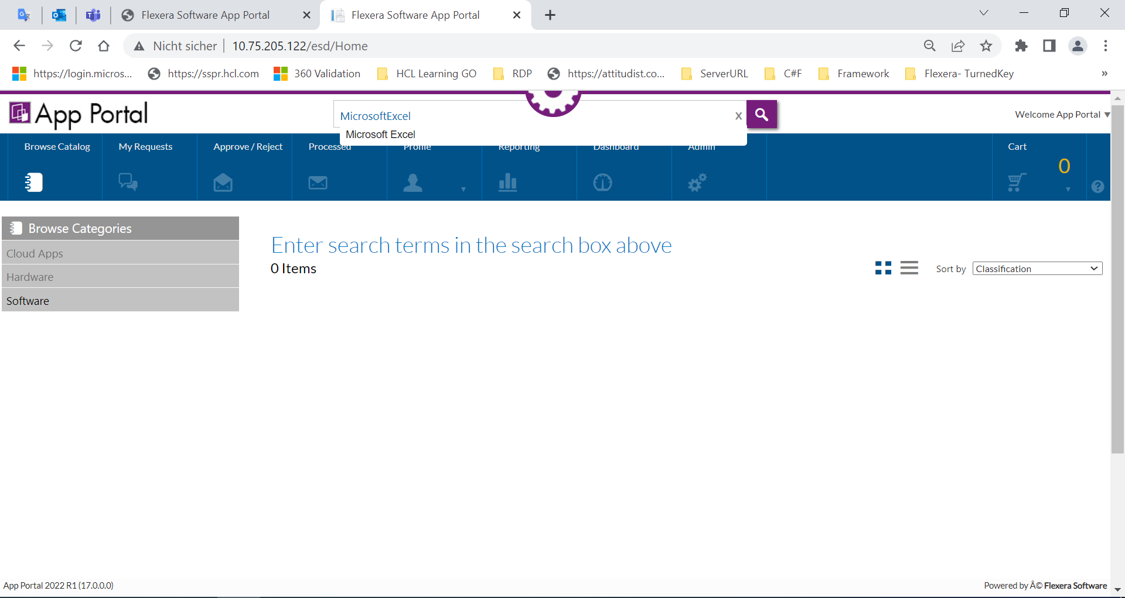

7. Disable history option and launch AP again and observe that the search history is NOT displayed. Now, search for any catalog item and refresh the browser and take the mouse cursor on the search text box and observe that the history is getting displayed. Now close the browser and relaunch the application again then the search history is NOT displayed.

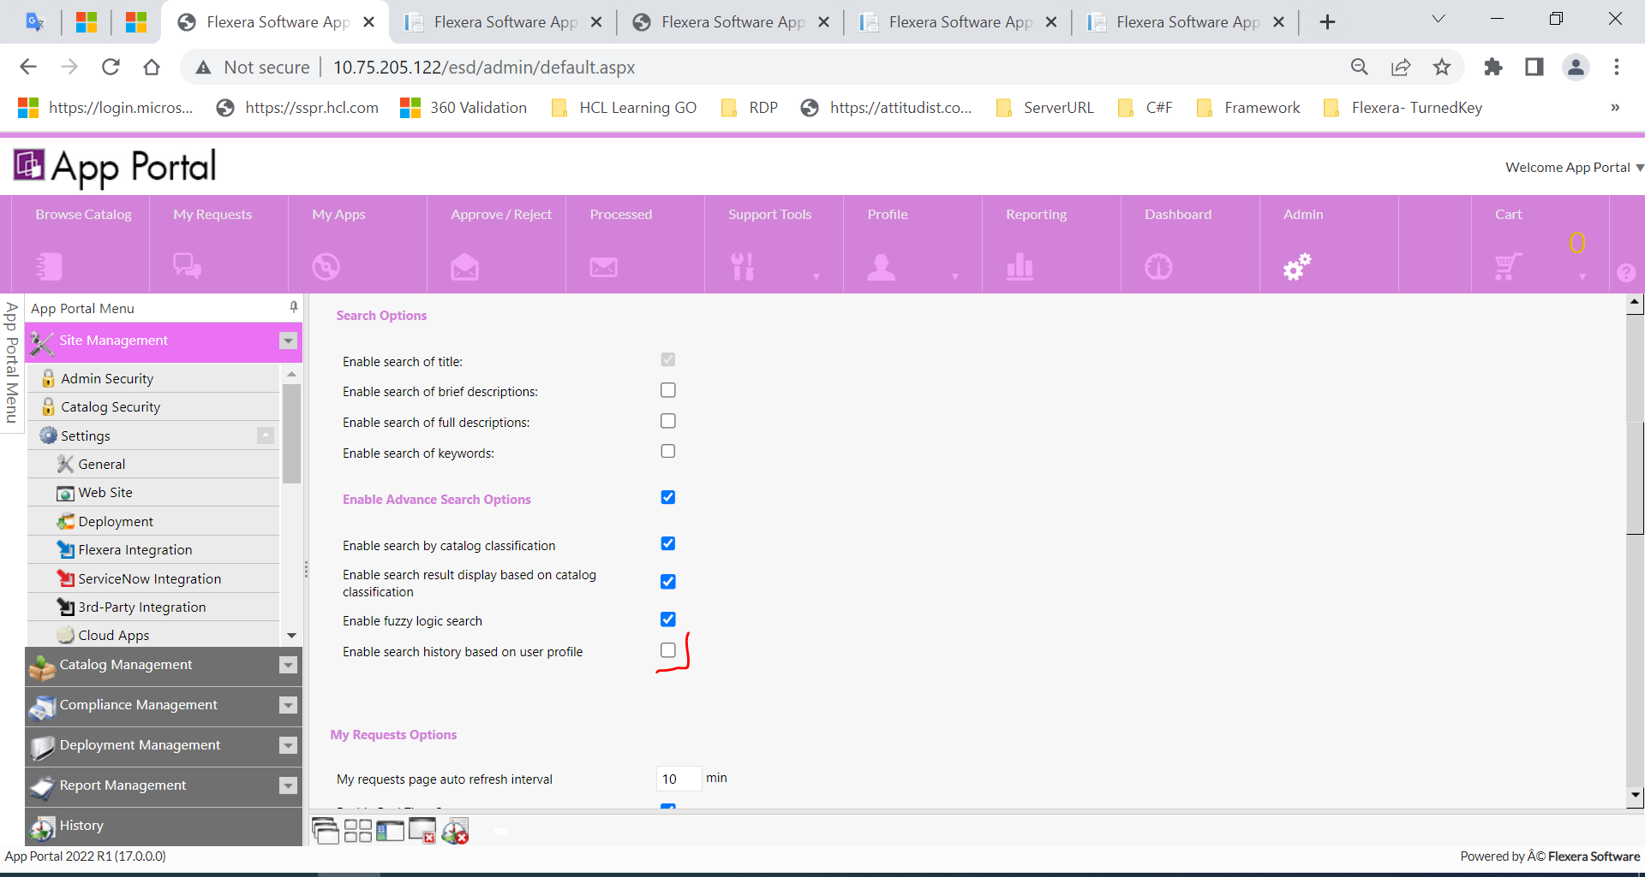

History not displaying

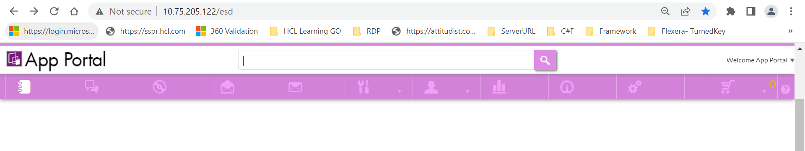

Search any items.

Refresh browser and click on search textbox, history not displaying

9. When ONLY ‘Brief description' is checked and all the advanced search checkboxes are checked then in browse catalog page the search result is NOT displayed and message gets displayed as 'There was no result for your search’.

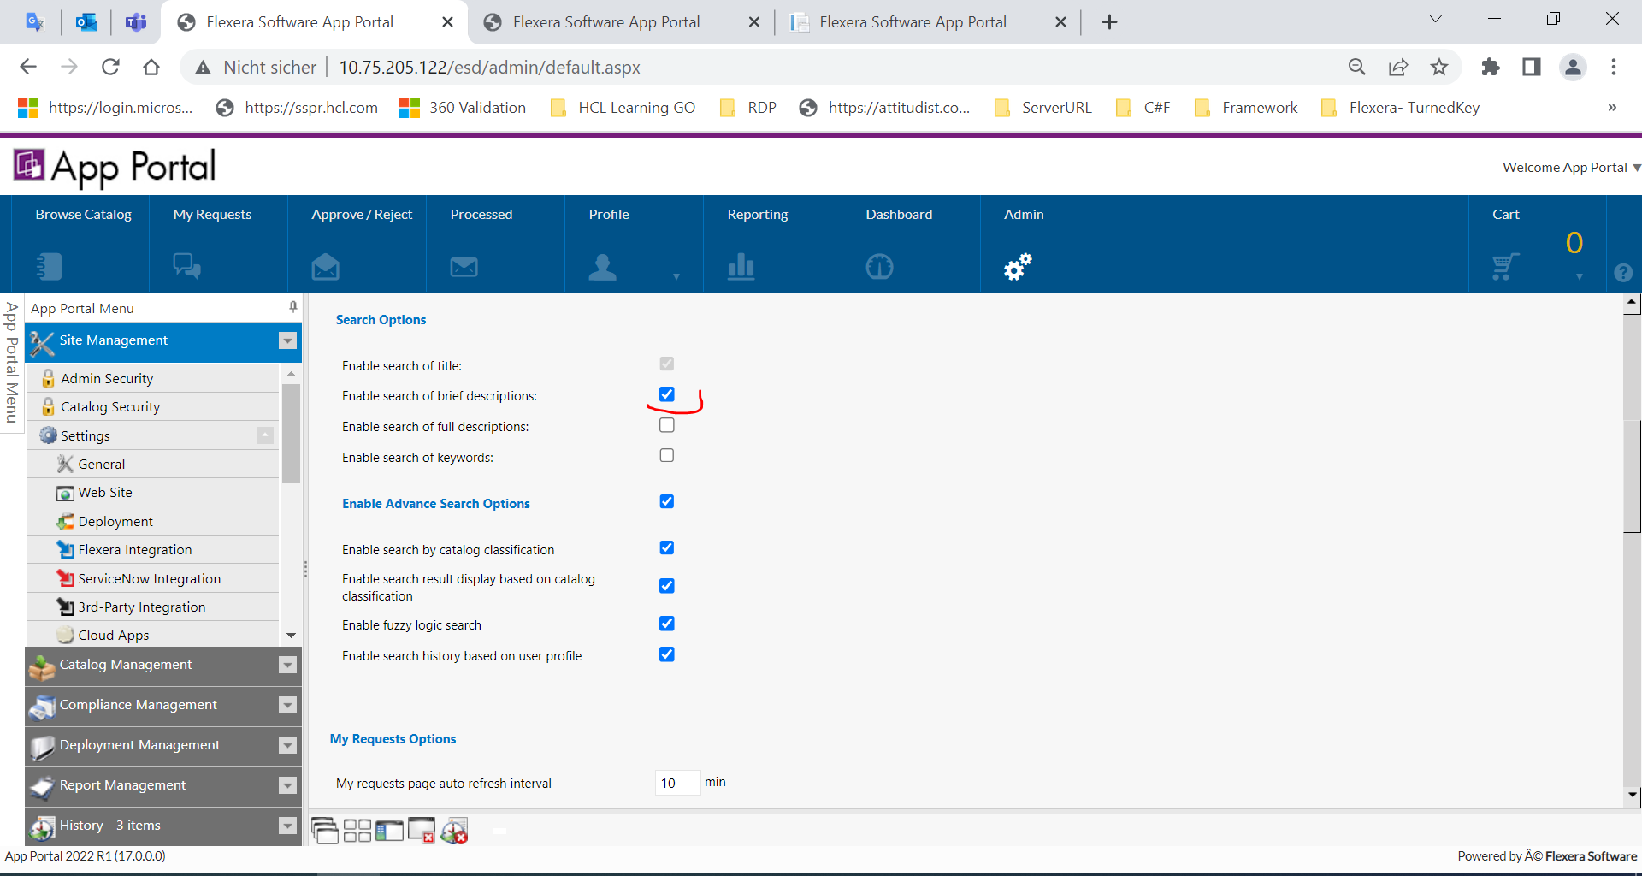

10. When ONLY ‘Full description' is checked and all the advanced search checkboxes are checked then in browse catalog page the search result is NOT displayed and message gets displayed as 'There was no result for your search’.

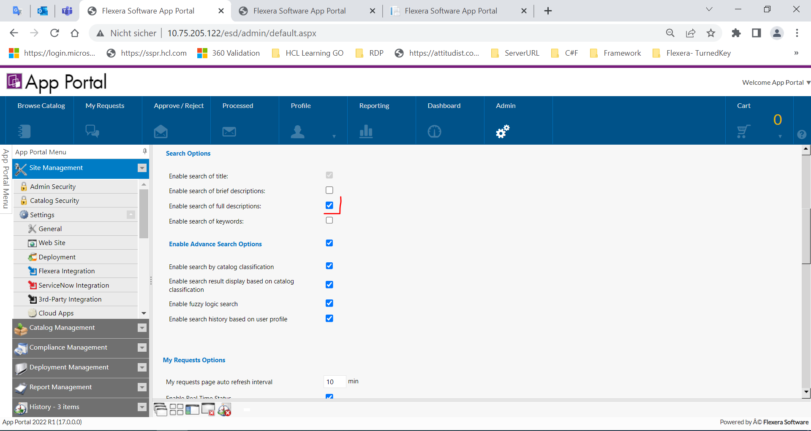

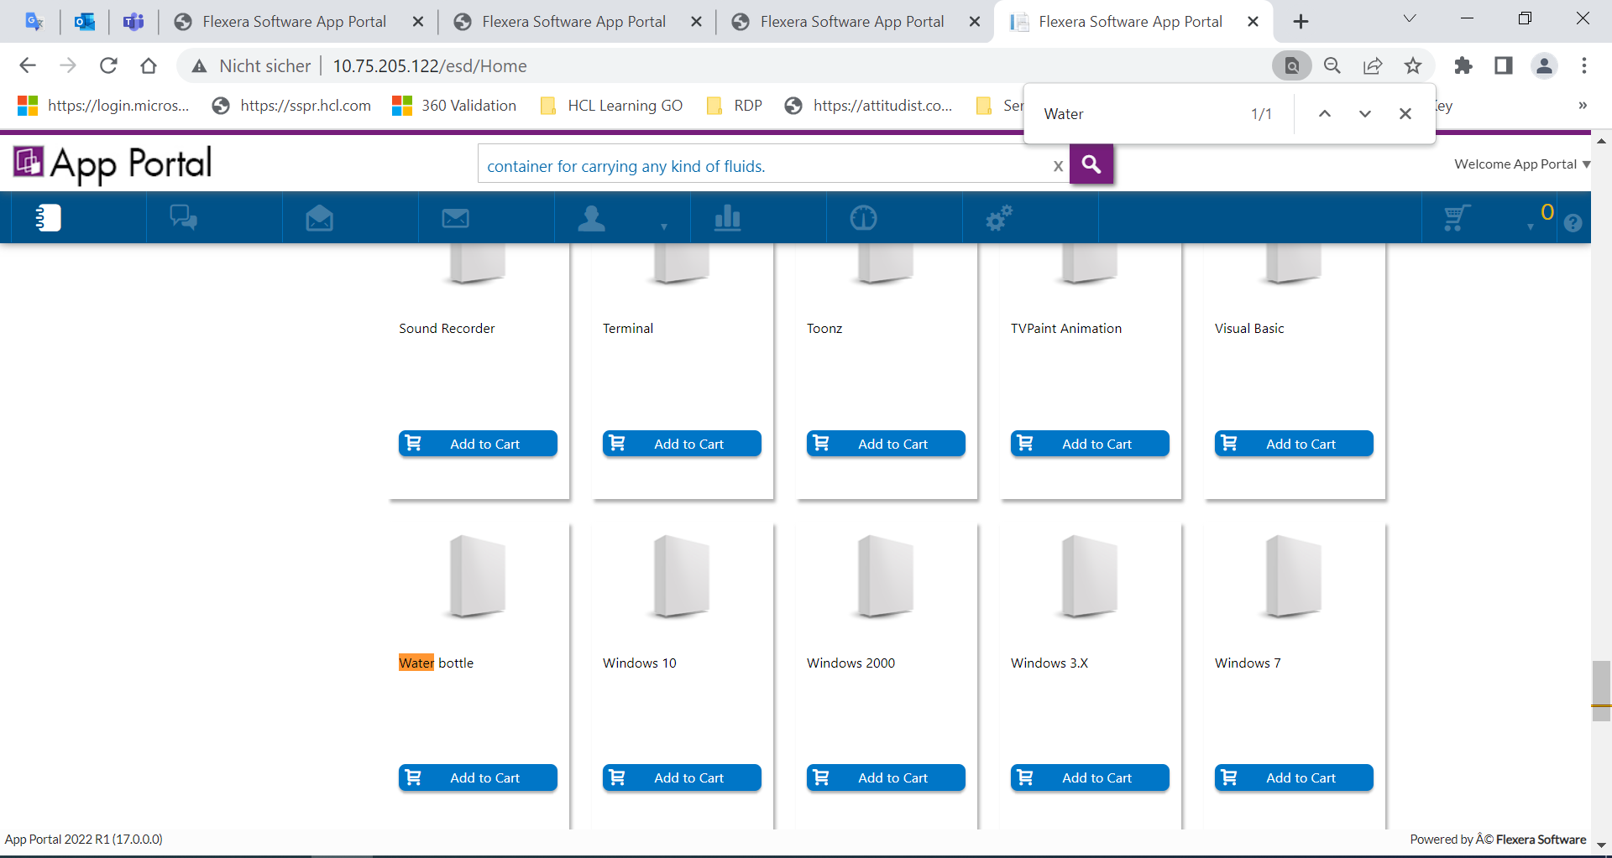

11. Keyword Basic Search Term  
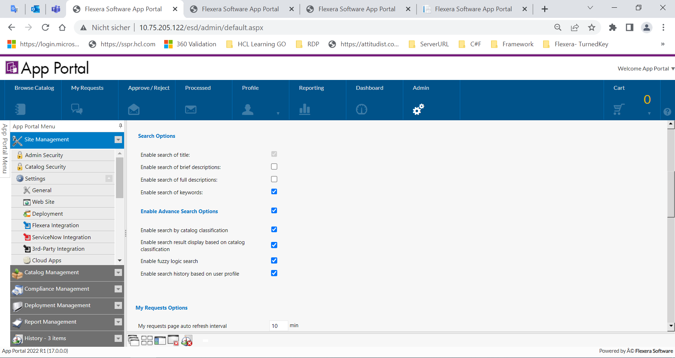

12. When catalog classification is created with more than one word then the search is NOT rendering the results in browse catalog screen.

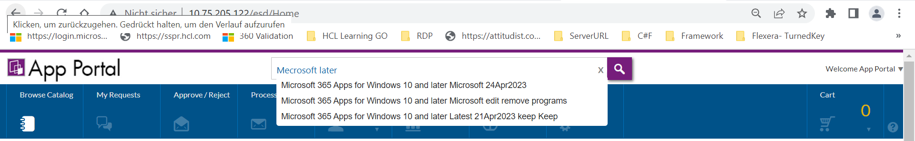

14. Corporate Branding the color selection option is NOT getting displayed.

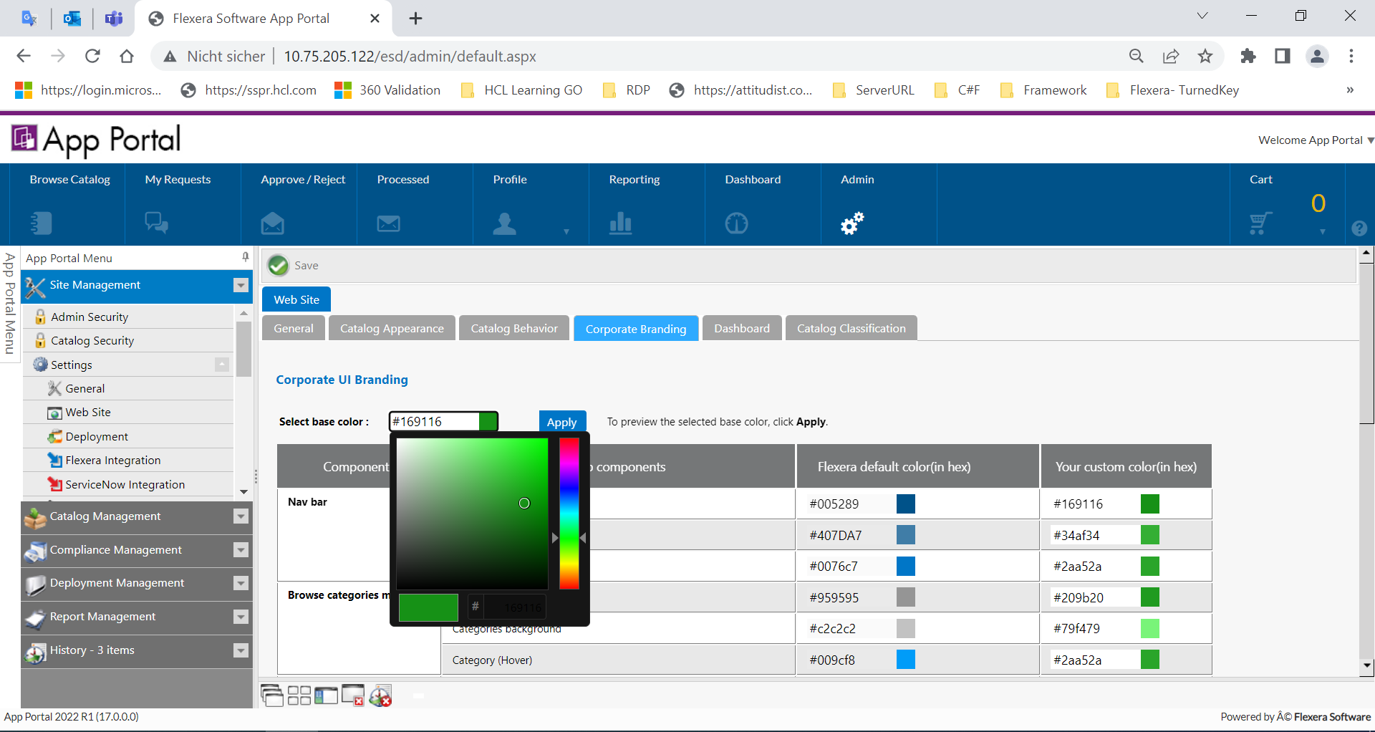

15. In Browse catalog screen in search text box if the searched item is not found that it says 'No Records Found'. Make it like 'No records found'. The letter 'R' and 'F' in small case.

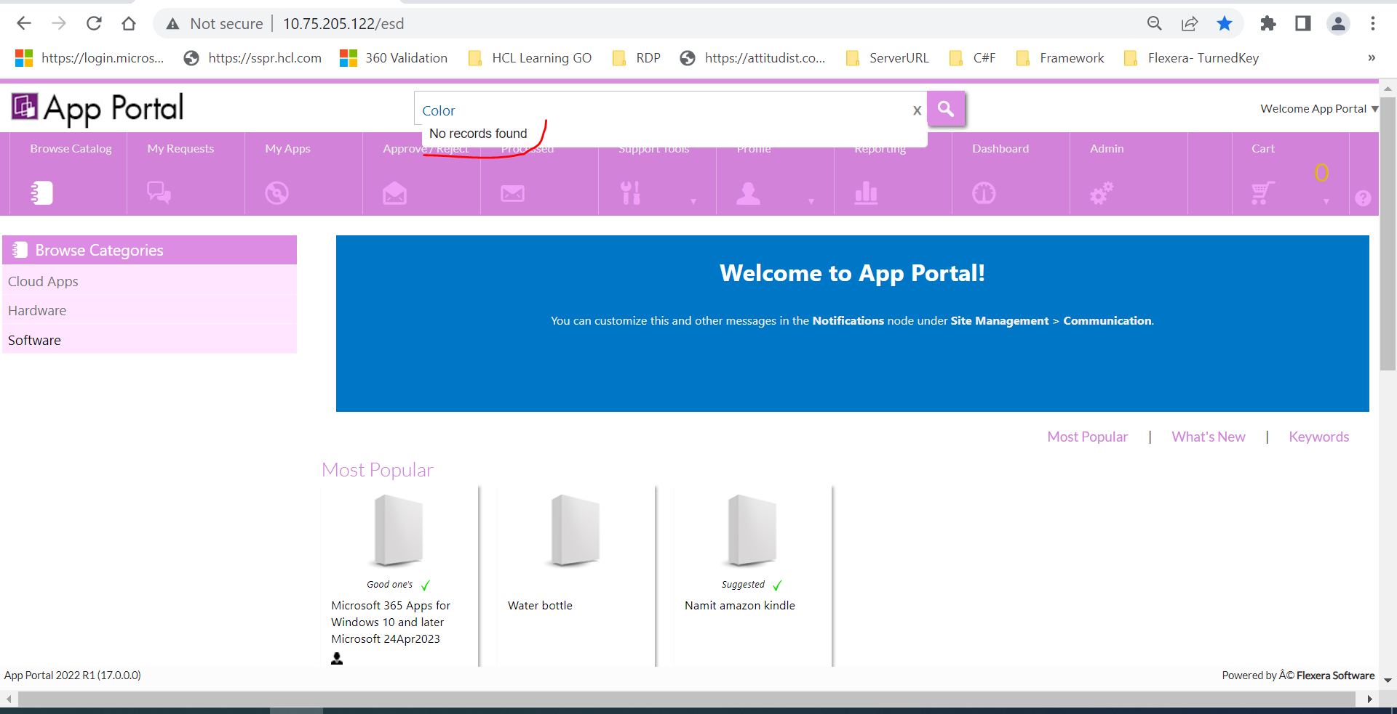

16. Difference in the count of catalog items that actually exists in admin side than the count showed in the 'Browse Catalog' screen.

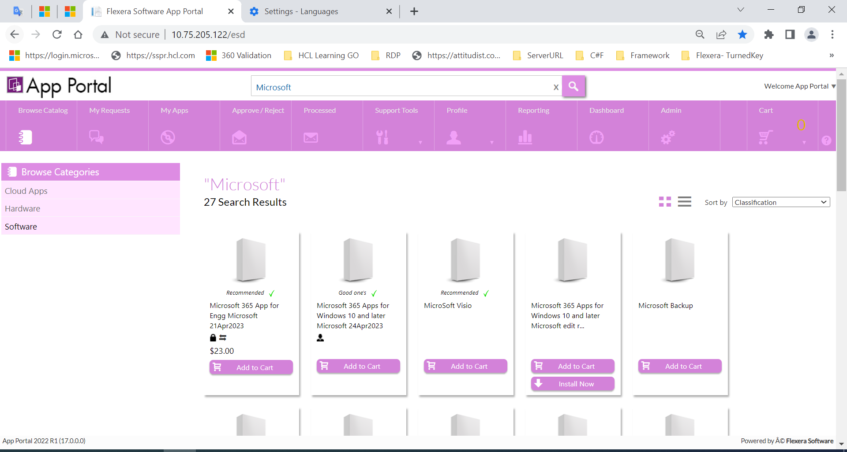

**Phase 1 delivery verification**

1. If Catalog item title is having two words and if any word is misspelled, then the search results are NOT getting displayed.

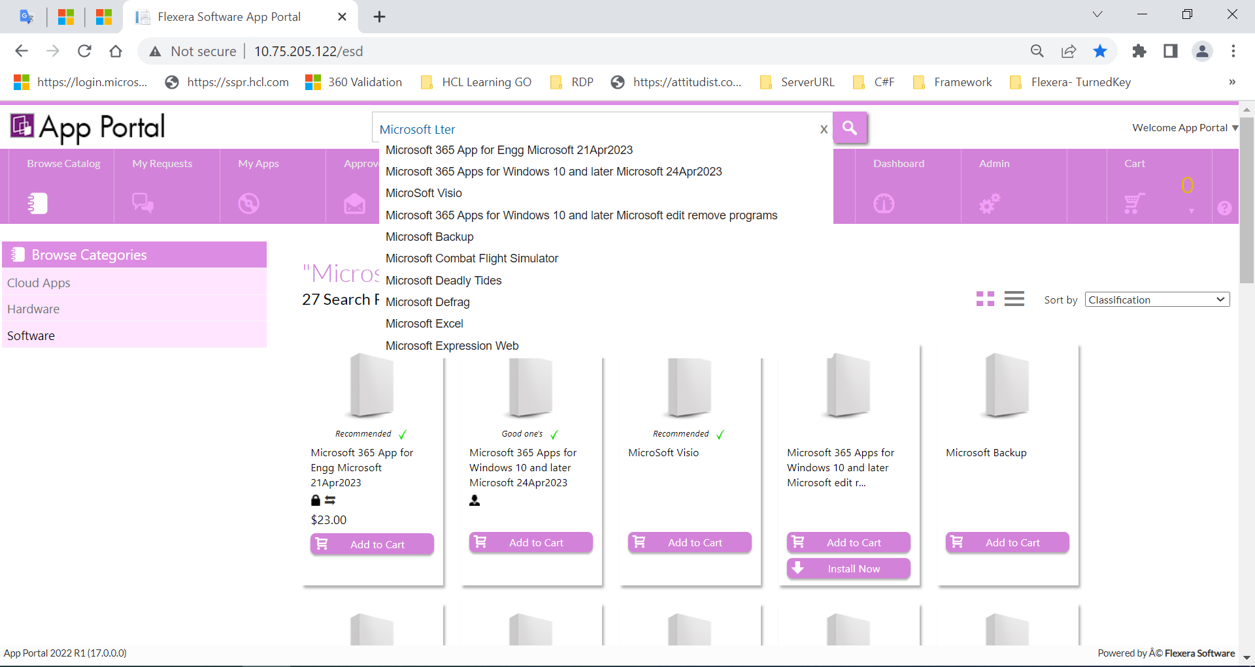

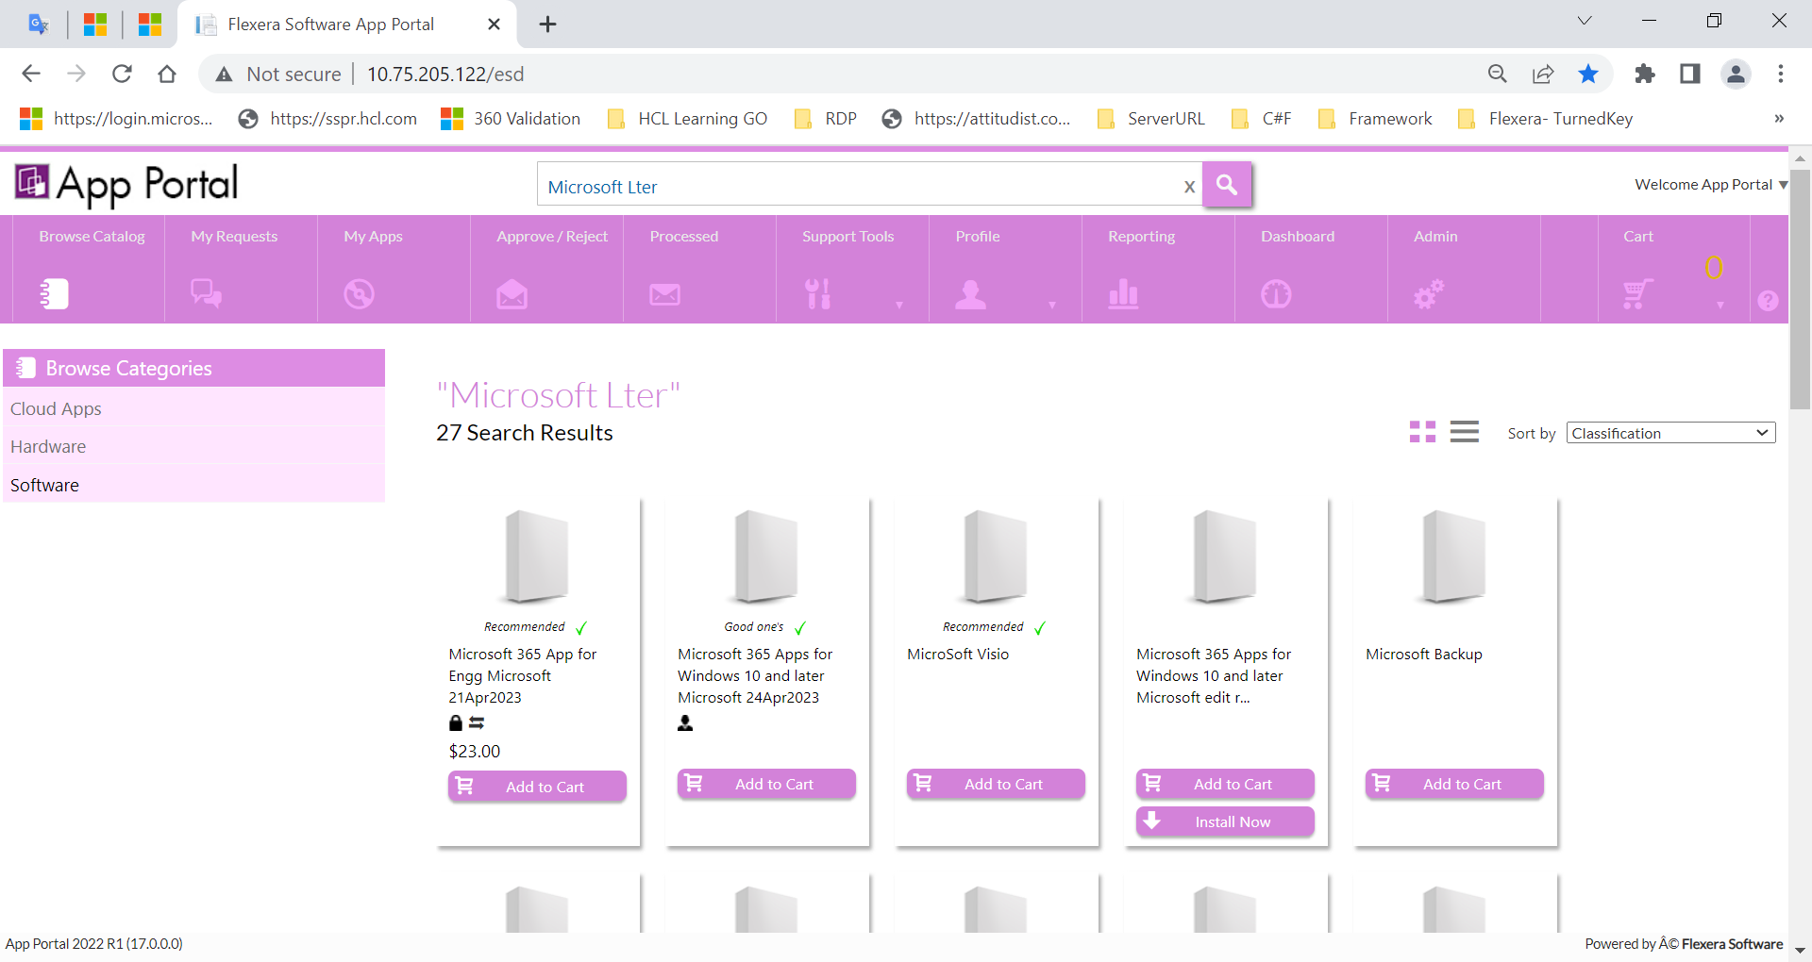

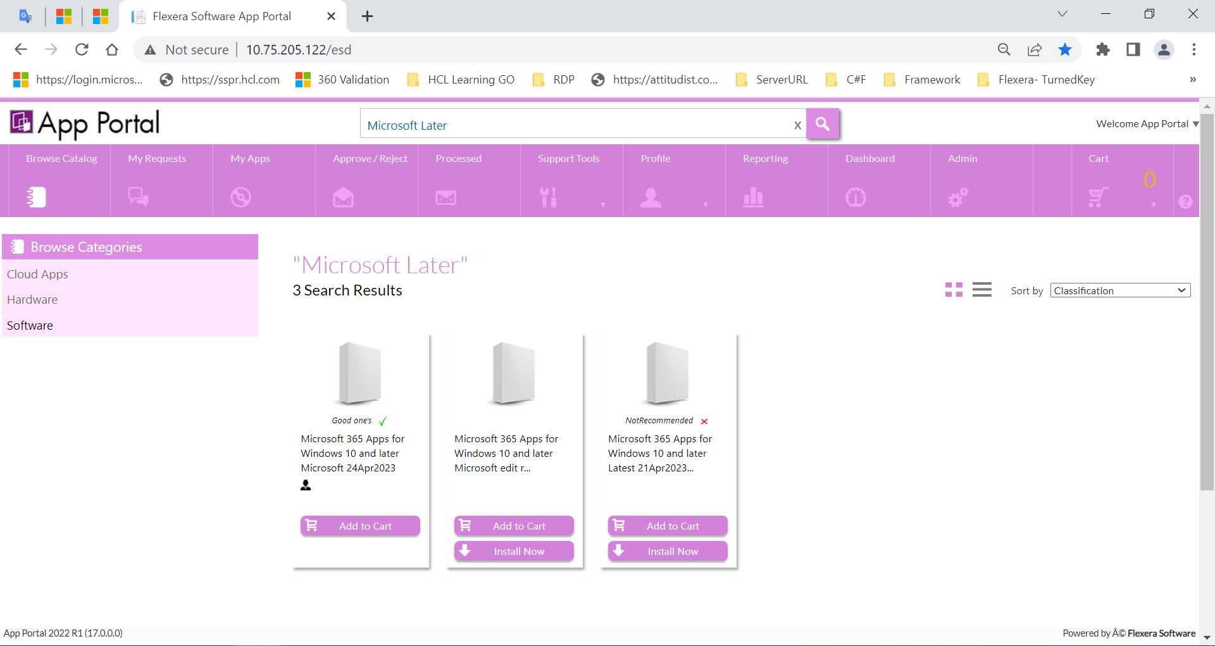

2. Advanced search in Browse catalog page is happening even when the 'Advance search' option is disabled.

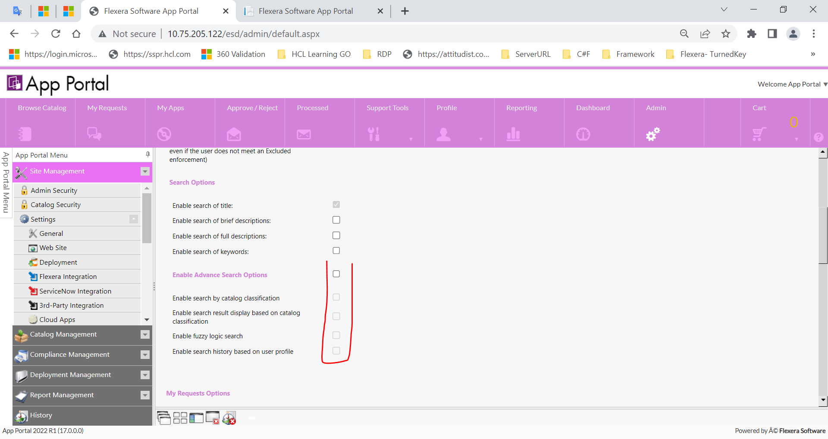

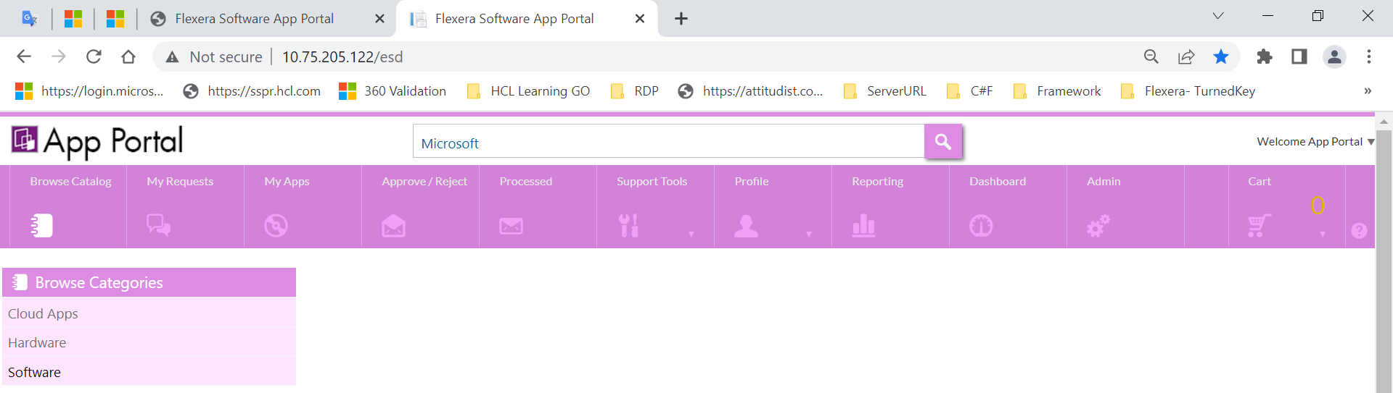

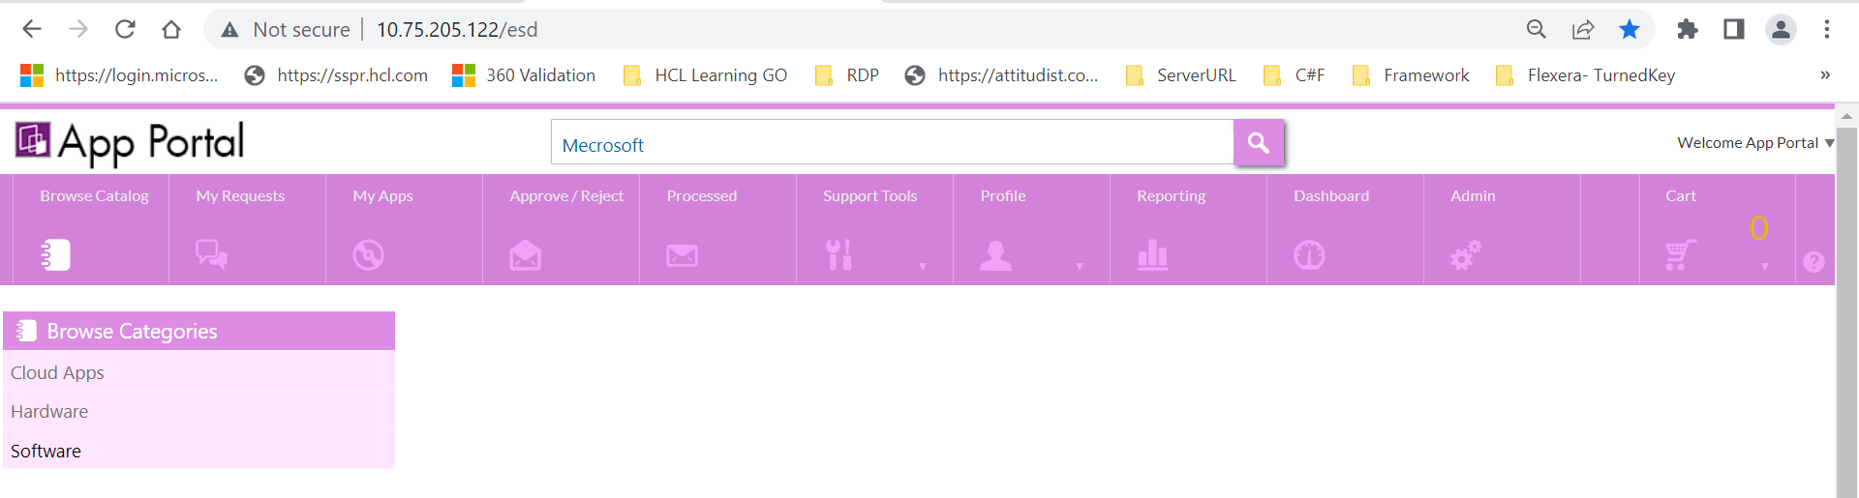

3. Even when the ‘Catalog classification' feature is enabled and when the ‘Enable search result display based on catalog classification’ is disabled then the classification texts are NOT getting displayed in the Browse catalog page.

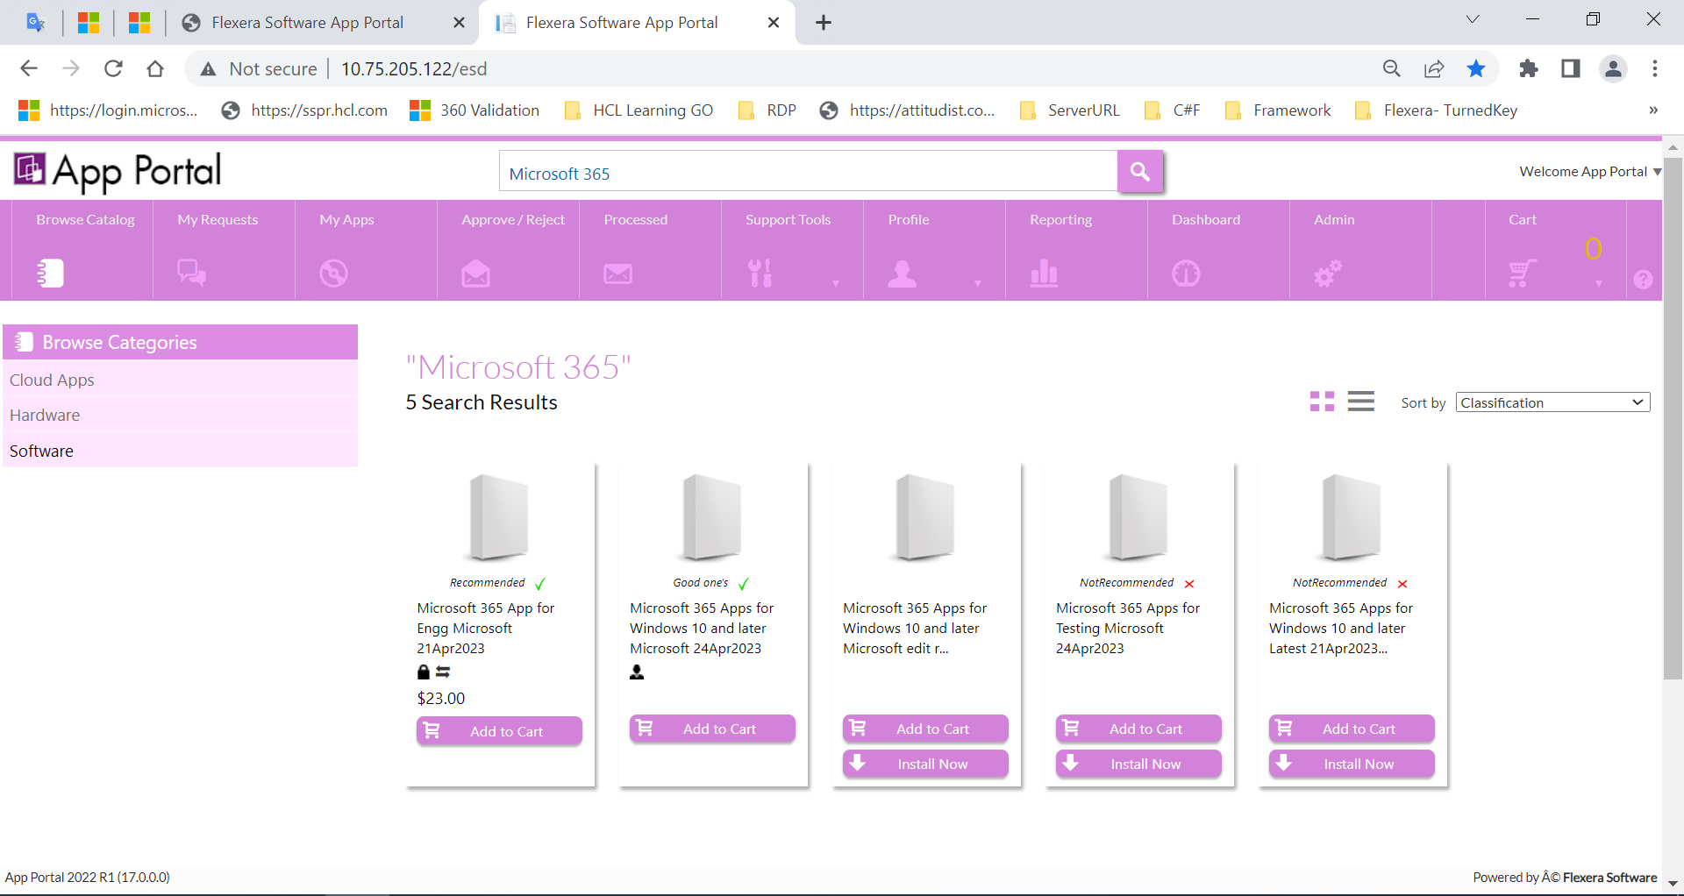

4. Disable the catalog classification feature still we are able to see the ‘preferred' and 'non-preferred’ texts in Browse catalog page.

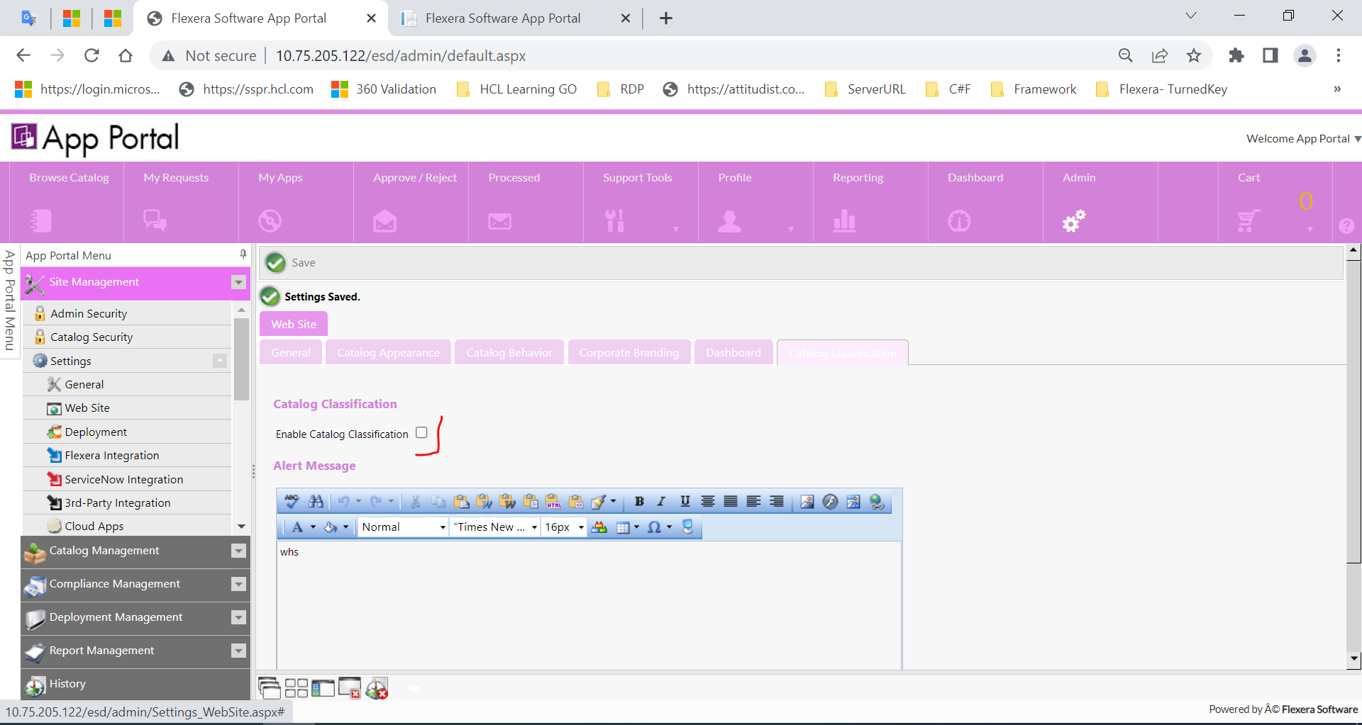

5. Even when the ‘Catalog classification' feature is enabled and when the ‘Enable search result display based on catalog classification’ is disabled then the 'Classification' sort option is NOT getting displayed in Browse catalog page.

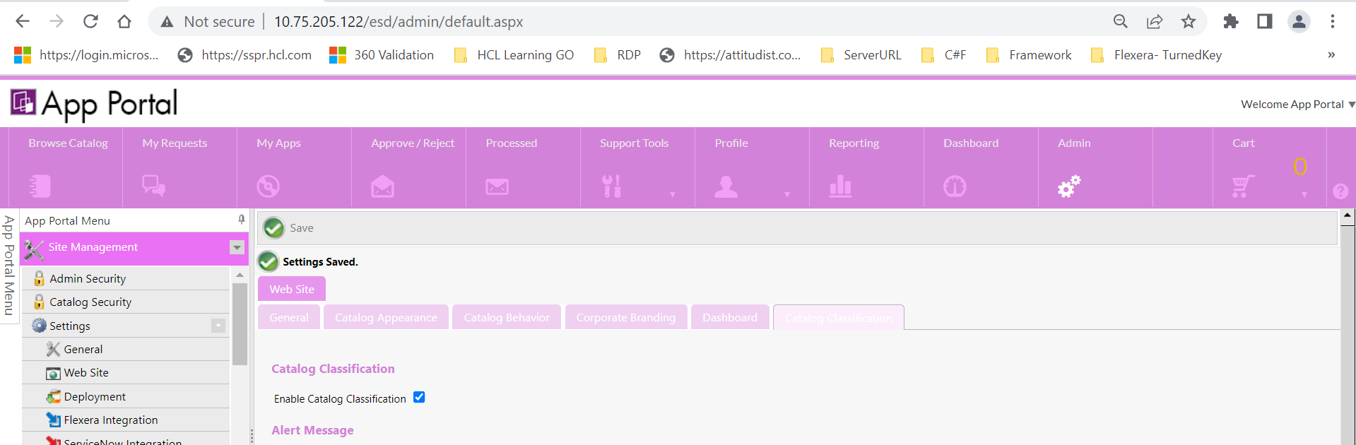

6. Cloud catalog items are not getting displayed in search results when catalog classification and advance search options are enabled.



